**Lab05 - Vector data**

Instructor: Byungyun Yang, TA:

In this exercise, we will learn what vector data is and perform simple data editing. Then use what you learned to create your own map. **Please answer all the questions at the end of this exercise.**

**Learning objectives:** When you have completed this lab, you will be able to

1. Feature of Vector Data
2. Using the Geopandas and other Package
3. Working with Map Projections
4. Mapping
5. Export your map to pdf file

**1.0 Feature of Vector Data**

Vector data is one of the ways of representing geographic information by expressing geographic space as geometric objects such as points, lines, and polygons.

The main features of vector data are as follows:

**Positional accuracy**: Vector data can accurately represent geographic location using coordinates. These coordinates play an important role in determining the accuracy of spatial data.

**Shape of objects**: Vector data is represented as geometric objects such as points, lines, and polygons. These objects are useful for visualizing and analyzing geographic information.

**Attribute information**: Vector data includes attribute information about the objects. For example, if the components of geographic space are buildings, attribute information may include the name, address, size, and other information about the buildings.

**Data size**: The size of vector data depends on the spatial resolution and the number of objects. The larger the number of objects or the higher the resolution, the larger the data size.

**Ease of analysis**: Vector data includes both positional information and attribute information about objects, making it very useful for analyzing geographic information. For example, analysis tasks such as finding the largest building in a geographic space can be performed.

**2.0 What is the Geopandas Package**

**Geopandas is a spatial data analysis tool** that builds on the Pandas library and provides additional functionality for working with spatial data.

**First**, Geopandas supports various spatial data formats such as shapefile, GeoJSON, GML, KML, etc., and can read and write these formats into Pandas dataframes for spatial data analysis.

**Second**, This provides various functions, such as visualization of geographic information, querying spatial data, performing spatial operations between datasets, and more. Additionally, Geopandas internally uses the Shapely library, which offers various spatial operations that can be uses within Geopandas.

**In conclusion,** Geopandas is a useful tool for working with spatial data and can be utilized in various fields, such as geographic information visualizationm analysis, simulation, and more.

**2.1 Using the Geopandas and other Package**

In this exercise, we will be working with vector data, one of the main data types used in GIS. Therefore, we will use two packages, geopandas and matplotlib, to handle vector data in the Python environment. In addition, we will also use the pathlib package for efficient file management.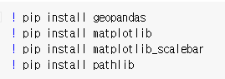

Install the required packages in the Colab environment using the above code, apply the packages as shown below, and also set the file path: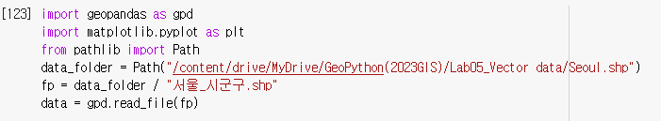

In this case, the Path("...//...//") path refers to the file path where the individual has saved the exercise materials. We set the "서울_시군구.shp" file, which will be used in this exercise, as the data.

Next, we will check the attribute information of the shapefile and visualize it.



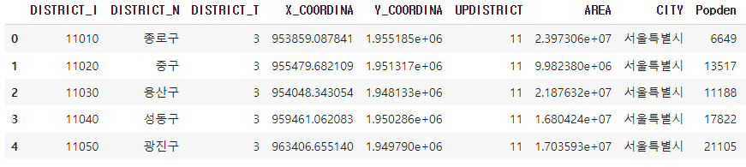

Since we used the **“data.head()”** code, we can only see the top 5 attribute information instead of the entire information. Through this, we can confirm that the "서울_시군구.shp" file contains information such as district names, longitude and latitude, population density, and so on.

Now that we have checked the attribute information of the shapefile, let's use the matplotlib package to visualize the shape file.

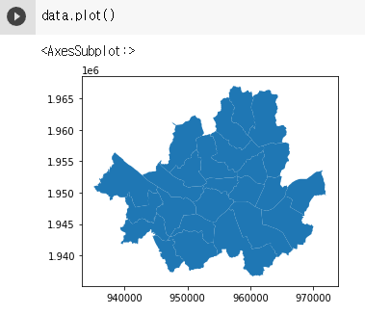

**3.0 Working with map projection**

If the shape file was visualized successfully, we are ready to create a map. Therefore, we will first set the coordinate system of the map and then create the map

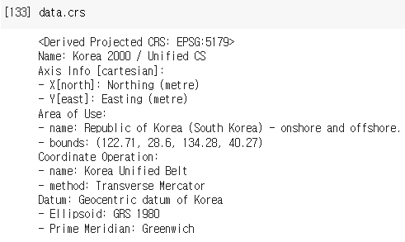

The code **"data.crs"** allows us to check the projection currently applied to the shape file, and we can see that the current projection applied is "Korea 2000 / Unified CS", with Datum "GRS1980".

Although the current projection applied to the shapefile, "Korea 2000 / Unified CS" with Datum "GRS1980", is appropriate for mapping South Korea, we will create a map of Seoul projected in WGS84 to demonstrate how to change projections and the effect of using an inappropriate projection.

To create a shapefile projected in WGS84, you need to make a copy of the original shapefile and reproject it.

To change the projection of the copied shapefile to WGS84

Afterward, if you check the projection of the file, you can confirm that it has been changed to WGS84 as shown below.

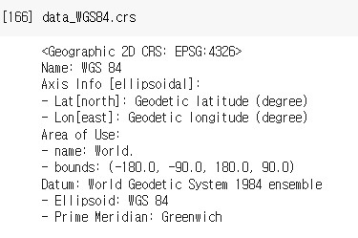

Now, let's create two maps with different projections and see the differences.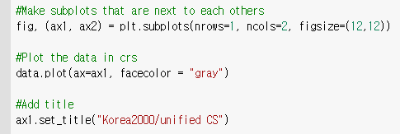

Using the above code, we can create the first map with the Korea 2000 projection.

*[fig=figure: size of the data frame], [ax=axes: map layout], [facecolor=map color], [title=map title].*

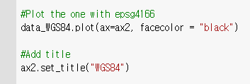

Let's create the second map with WGS84 projection, just like how we created the first map with Korea 2000 projection.

Finally We can the basic map-making process by adjusting the aspect ratio of the layout and reducing the blank space, for both the first and second maps.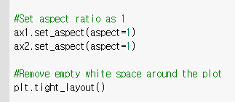

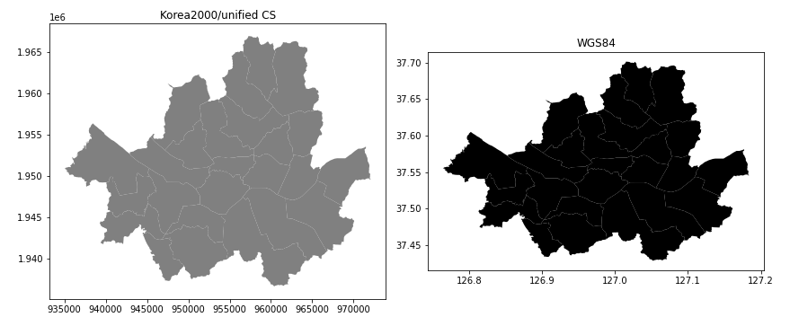

**You can easily see the differences between the two maps that were created using different projections. Please write your answer in a Word document or Google Doc and submit it as part of your assignment.**

**4.0 Mapping**

The maps visualized above have the form of maps, but they cannot be considered maps as they do not contain basic map elements. Therefore, we will create a map with map elements and complete the practice.

First of all, we have confirmed that we need to use the shape file projected with Korea2000/Unified CS to create the Seoul map in the previous steps, so we will use **"data" instead of "data_WGS84"** to write the code.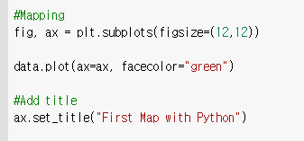

First, create the map frame and title of the map as we did before, and create a north arrow, one of the map elements.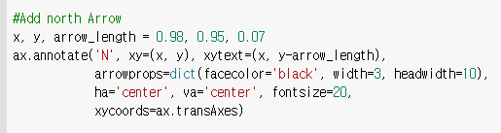

*[x = x-coordinate of the north arrow], [y = y-coordinate of the north arrow], [arrow_length = length of the north arrow], [facecolor = color of the north arrow], [width and headwidth = width of the north arrow and the width of the arrowhead]*

Next, we will add a scale bar to indicate the scale and finalize the map.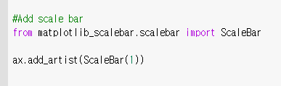

We can indicate the scale using the matplotlib_scalebar package, so let's apply the matplotlib_scalebar package and create the scale bar.

If the above code is successfully completed, the following map will be visualized.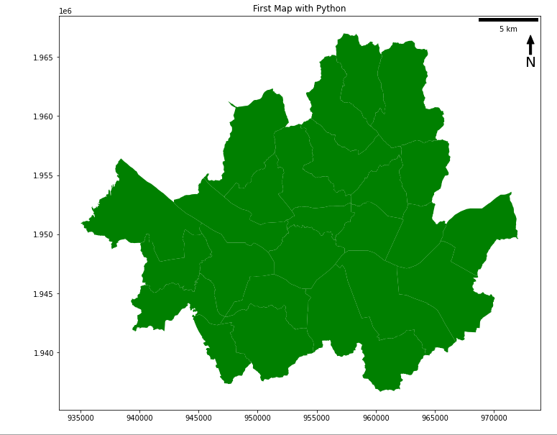

**5.0 Export Your map and Word file**

**Assignment**: There are two submissions to get a full credit. First, in a **Word Document (Lastname_Lab05report.docx)**, answer these questions. Second You are required to **create a map with your own style** based on the practical materials, and submit it as a PDF file with your Word document (or Google document). The practice file is worth five points.

Q1. Vector Data의 특징 3가지를 서술하시오.

Q2. Korea 2000 / Unified CS 를 투영한 지도와 WGS84를 투영한 지도의 차이점은 무엇인가?